SVCR GOVERNMENT DEGREE COLLEGE, PALAMANER
A Report on the Training pertaining to the Language and Soft Skills
English is treated as the global language and language of employment opportunities. If students are effective in terms of English communication ability, students can be prospective employees. This is because they will get the job opportunities with the communication ability they possess. In view of improving the communication ability and the required soft skills the department of English conducted a training program on the enhancement of communication and Soft Skills. The programme was commenced on the 30th October,2023 under the umbrella of Jawahar Knowledge Centre.
Objectives:
- To introduce hoe important English Communication
- To make the students understand English is essential to learn English Communication
- To convert the students effective speakers in English.
- To elucidate to students how to inculcate the situations to learn the language
- To improve communication capability and grammatical accuracy
- To make the participants use language non- consciously and in real time occasions
As a part of the programme, Students from different streams were allowed to take part in it. The programme was inaugurated by Dr. M. Venkatesulu, Principal, in the JKC Lab. On this occasion, he said that all the students who joined the training should utilise the opportunity and improve the required ability of English communication. He added that students could improve their employability only when they were good at English communication. The faculty members from the department of Political Science and Computer Science participated in the event. So as to develop the students’ efficacy in communicating in Language, the importance LSRW skills were emphasized.

Out Comes:
- This programme could provide the students a kind of exposure with regard to language
- Students could understand the grammatical concepts taught
- Some students got confused in the matter of grammar as they were taught the concepts first time.
- Participants were excessively interested in participating the activities like Role play, Group discussions and Debates
- This programme could be successful one in attracting the students to take part in the activities.
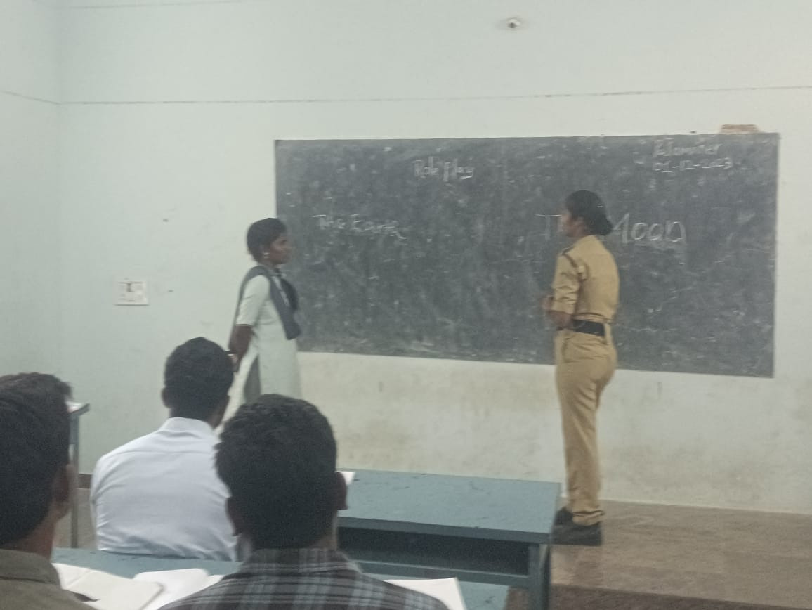
Conclusion: the training programme could provide a nice exposure to the participants. The participants were enthused in attending the classes. Since the students are primarily rural and Telugu medium back grounded and they have their regular programmes, they could not acquire the levels expected fully. Still, this is a successful program as students enjoyed learning and participation. It is recommended that they should have one more similar programme.

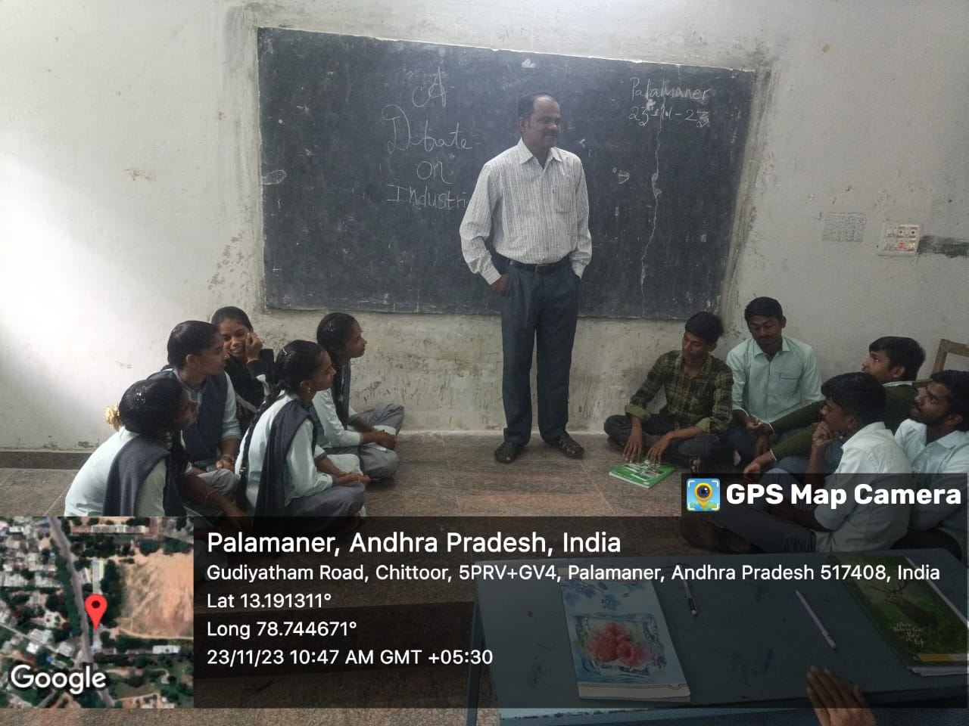
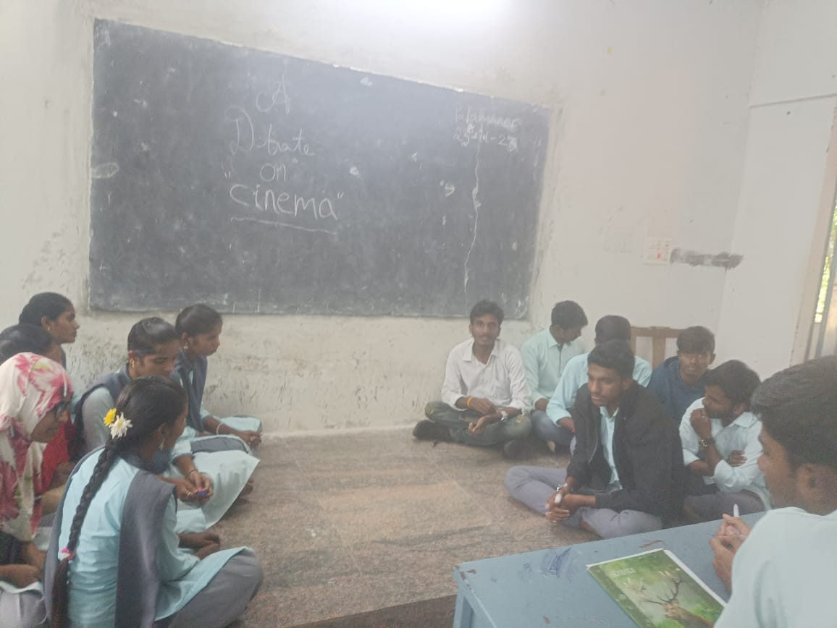
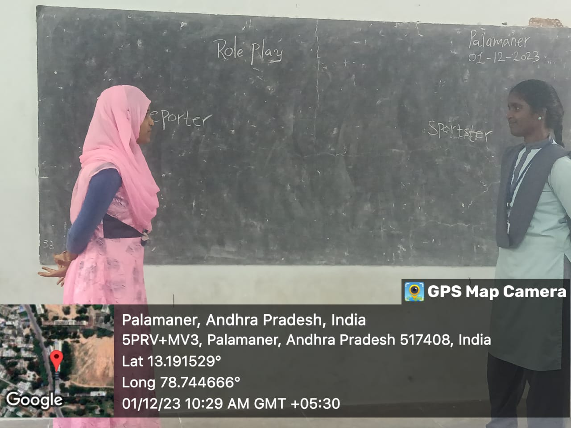

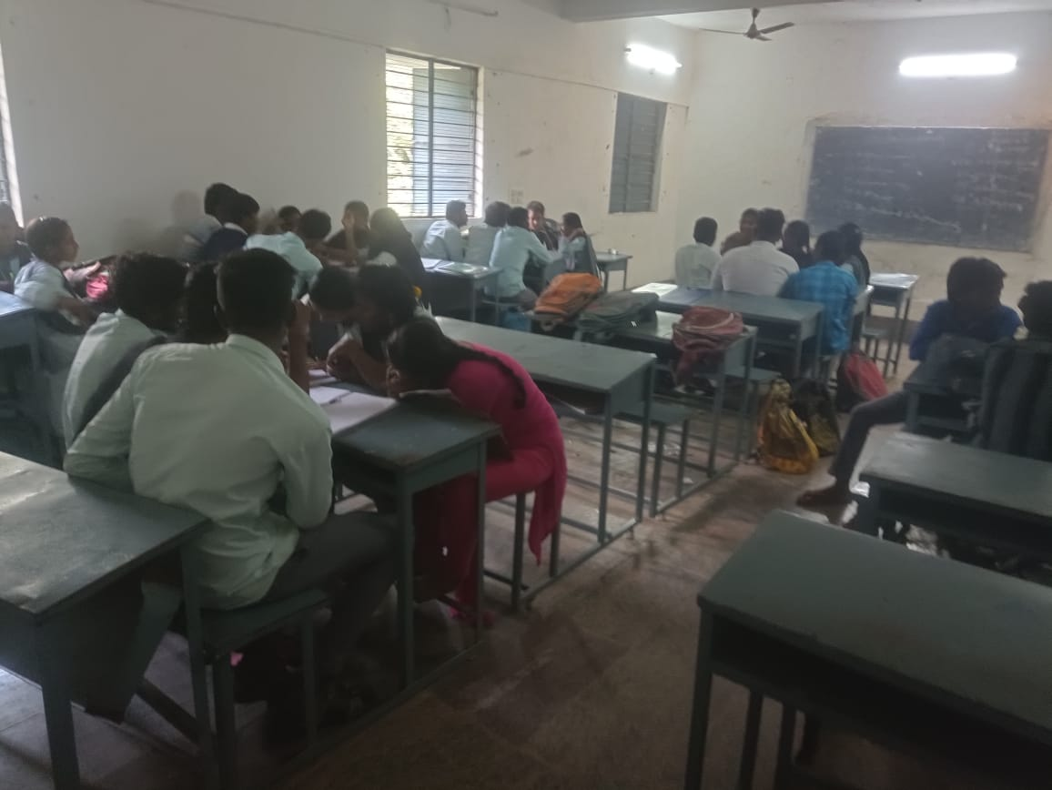
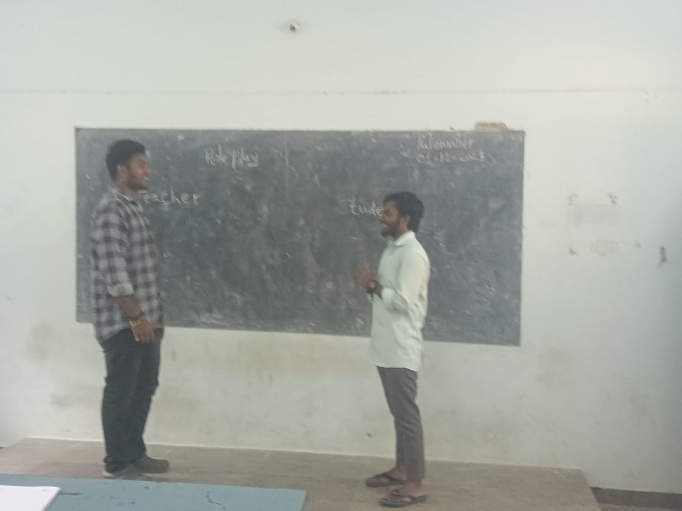
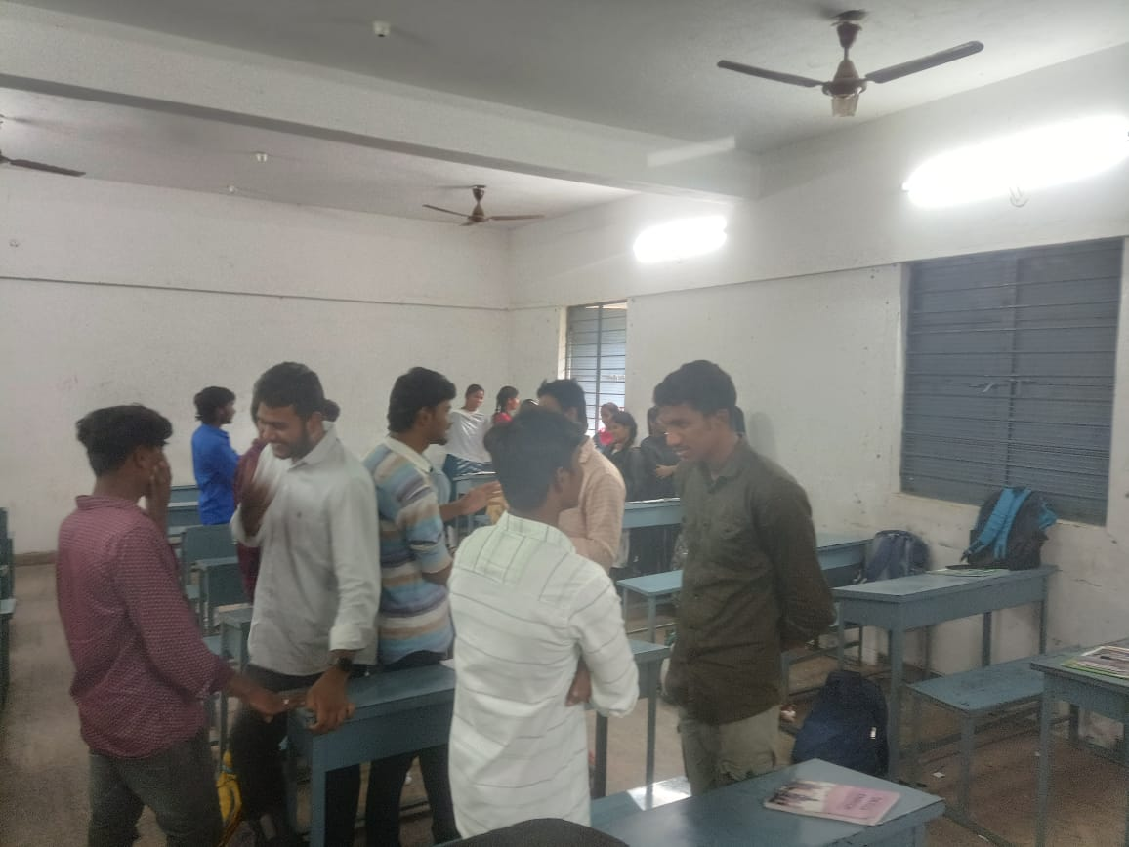

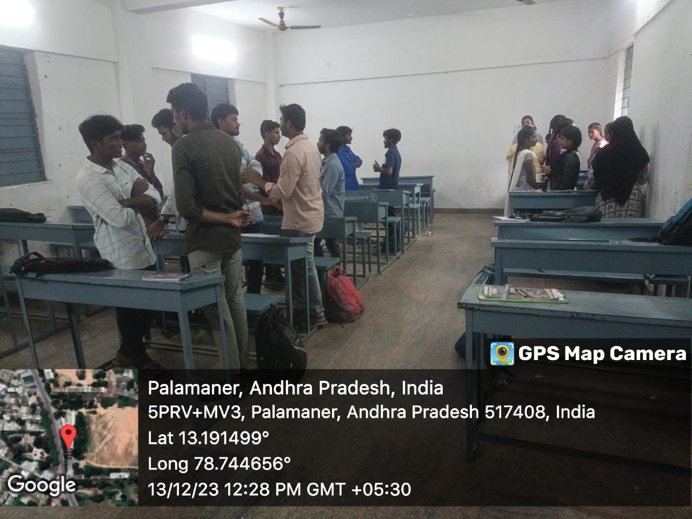
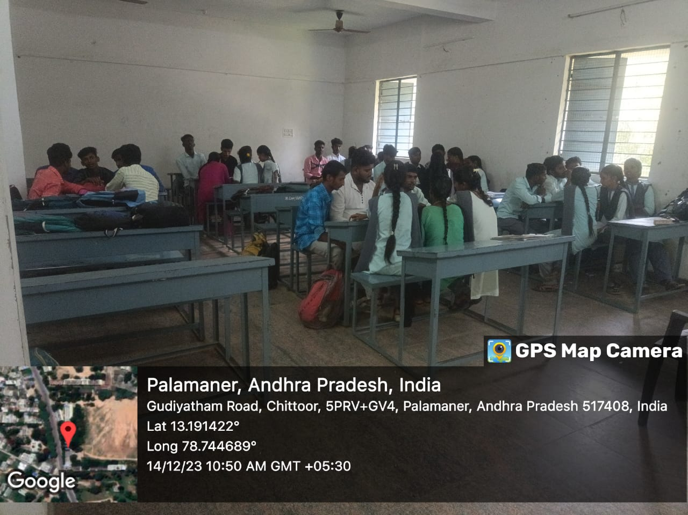

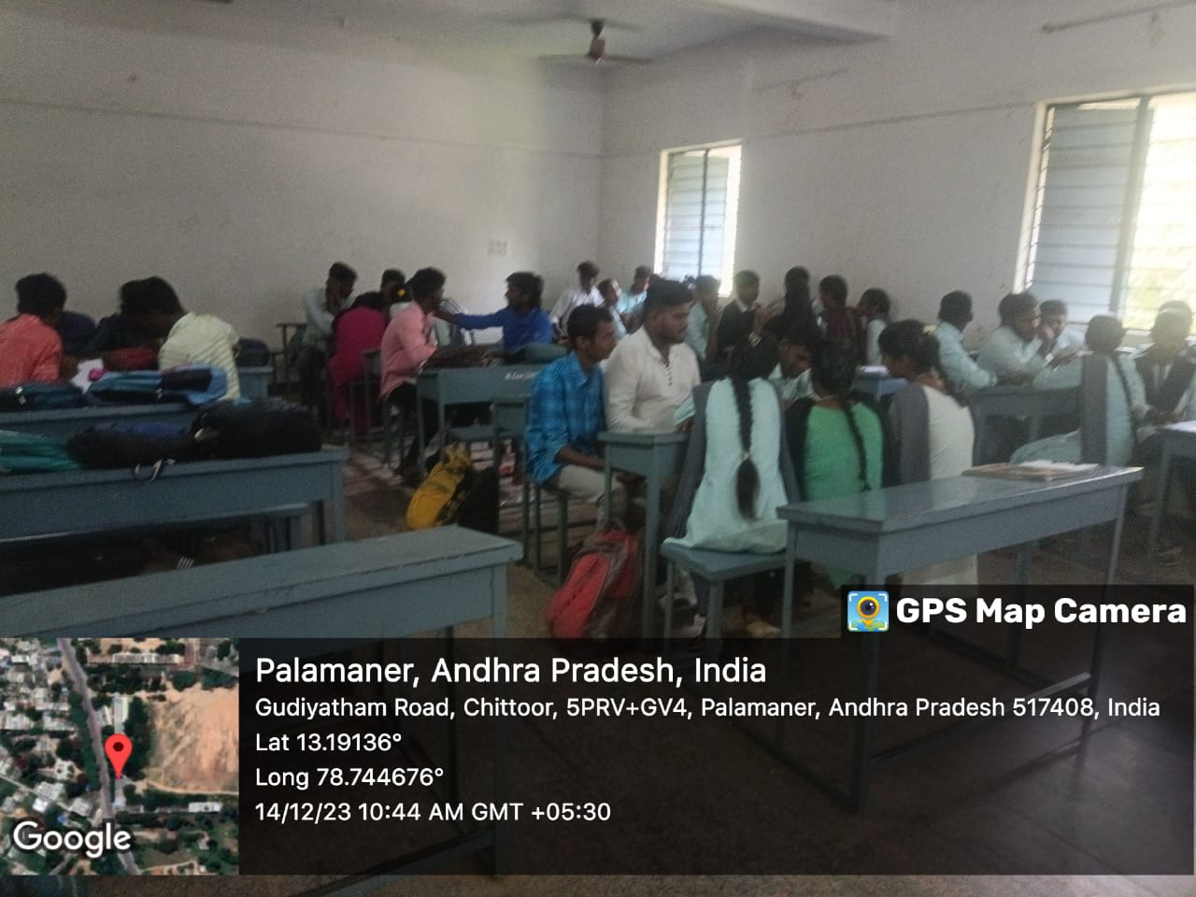
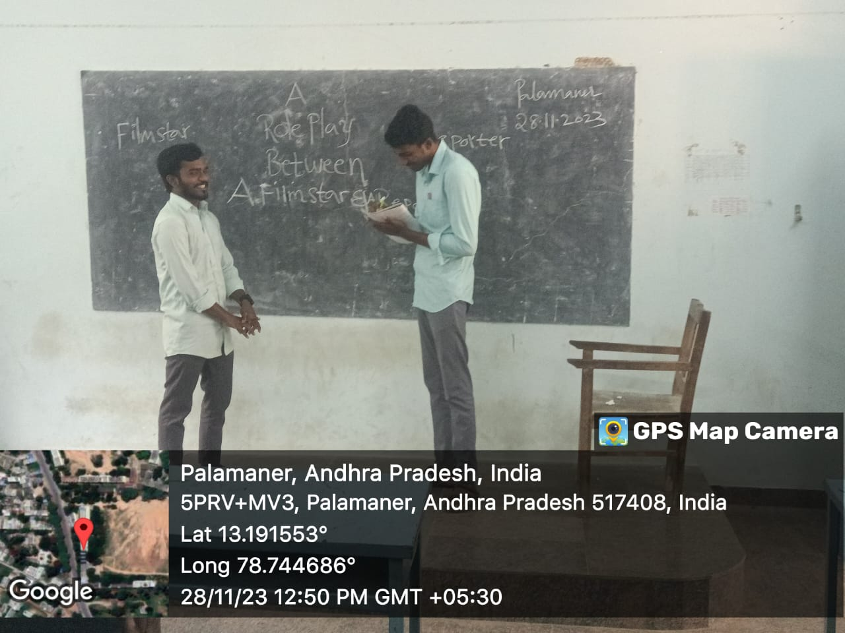
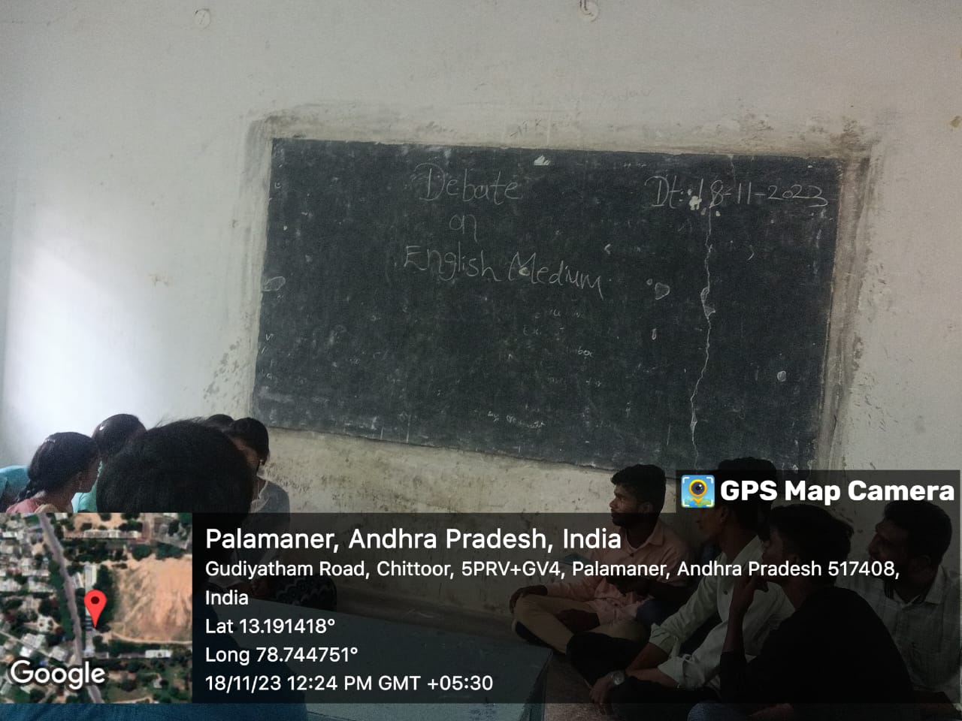
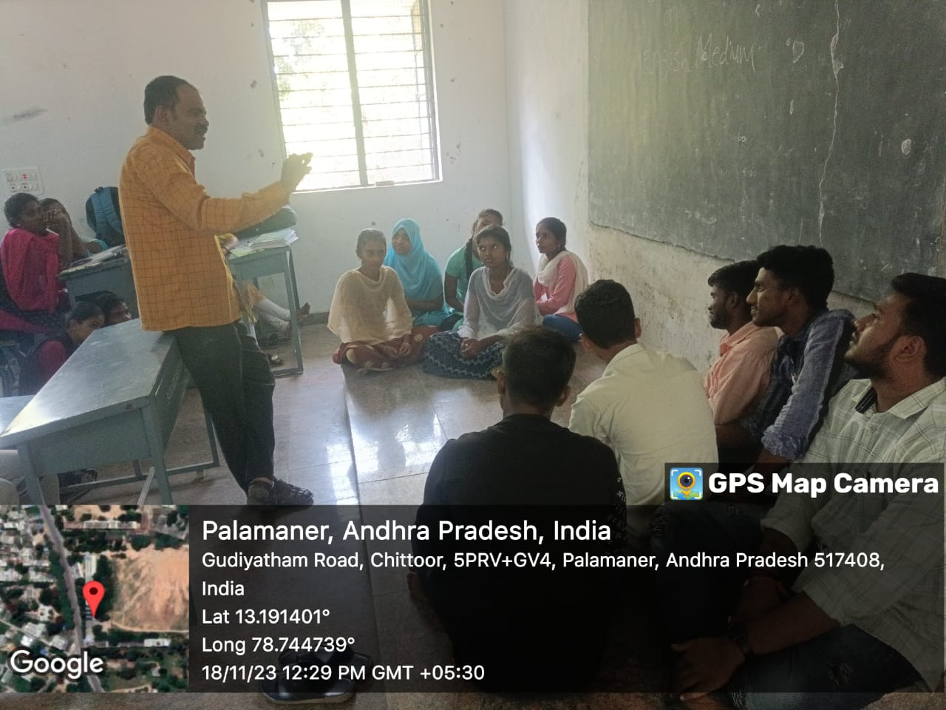

S.V. C. R. Govt Degree College-Palamaner Department of English
Certificate Course: Communicative English
Syllabus
Chapter one 7 Hours
- Articles
- Parts of Speech
- Prepositions
Chapter Two 19Hours
1 Tense
2 If clause
3 Voice
4 Degrees of Comparison
5. Sentence – Simple, Complex and Compound
Chapter Three 4 hours
1. Modals – Functions
2. Speaking Activities 10 hours
A. Role Play
B. Debate
C. Group Discussion

